Chip back potential is the level which bulk silicon is maintained by on-chip connection, or it is the level to which the chip back must be connected when specifically stated below. If no potential is given the chip back should be isolated.

.014”

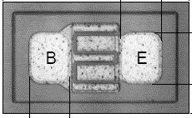

.009”

Top Material: Al
Backside Material: AuAs
Bond Pad Size: .003 x .004”
Backside Potential: COLLECTOR

APPROVED BY: DK DIE SIZE .009” X .014” DATE: 1/17/23
MFG: SILICON SUPPLIES THICKNESS .007” P/N: 2N2369A
DG 10.1.2

Rev B, 7/1

